

|  |
| --- |
| **FPT UNIVERSITY** |
| Capstone Project Document  Report 3  Project Management Plan |
| |  |  |  |  |  |  |  |  |  |  |  | | --- | --- | --- | --- | --- | --- | --- | --- | --- | --- | --- | | |  |  | | --- | --- | | **Group 18** | | | **Group Members** | Đào Bảo Long – Team Leader – SE60690  Lê Phúc Lữ – Team Member – 60563  Nguyễn Thanh Tùng – Team Member – SE60609  Nguyễn Tấn Đức – Team Member – SE60660 | | **Supervisor** | Nguyễn Trọng Tài | | **Ext Supervisor** | N/A | | **Capstone Project Code** | i-Deliver |   Build a Web Application  for manages all activities of  delivery service system by coach. | |
|  |
|  |
| Hồ Chí Minh City, January 2014 |

|  |
| --- |
| *This page is intentionally left blank* |



# Software Requirement Specifications (SRS)



## User Requirement Specification

The system should allow 4 types of actors, namely Guest, Customer, Staff, and System Administrator, and an abstract actor named Logged User, to interact with. Each of these types of user is granted a set of functions as specified below.

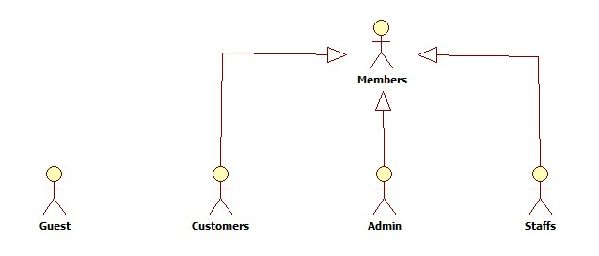

Diagram . Actor overview diagram



### Guest Requirements

A guest is an unauthenticated user of the website. He or she can:

* Log in with his authorized account;
* Register a new account;
* View, search for, and filter routes by a number of criteria that suit his or her needs;
* View details of an arbitrary routes.

### Logged User Requirements

A logged user is an authenticated user of the website (e.g., a user who logged on to the system with a valid username and password). They can:

* Log out;
* Change their own password;
* View and update their account details.

Note that that this actor is an abstract one and does not represent a real actor in practice.

### Customer Requirements

A Customer is a logged user (see 3.1.2. Logged User Requirement) and is given all the functions of a logged user. In addition, he or she is granted all the functions of a guest (see 3.1.1. Guest Requirement) except for the Log in and Register functions. A Customer also has his or her own set of functions:

* Create and submit the goods delivery requests;
* Cancel unwanted requests if they weren’t paided or approved;
* Edit submitted delivery information in a limit duration;
* Leave reviews about the service;
* Rate hotels by multiple criteria;
* Tracking for package (when the package left station, time left to be delivered, …);
* Make an online payment via third-party service.

### System Administrator Requirements

A System Administrator is a logged user (see 3.1.2. Logged User Requirement) and is given all the functions of a logged user. In addition, a system Administrator also has his or her own set of functions:

* Manage Staff accounts;
* Add more System Administrator accounts;
* Manage fee value and calculating formular;
* Statistics: get datas about revenue, performance.

### Staff Requirements

A Staff is a logged user (see 3.1.2. Logged User Requirement) and is given all the functions of a logged user. In addition, a system Administrator also has his or her own set of functions:

* Manage all requests: approve, reject online requests, create new, edit and cancel offline requests;
* Manage all related information about routes, stations, trips and coaches;
* Arrange and schedule for packages delivery;
* Searching for information about requests, routes, stations, trips and coaches;
* Manage comments and rating: delete violated comments and clear spam rating;
* Statistics: get datas about revenue, performance.

## System Requirement Specification (Specific Requirements)



### External Interface Requirements



#### User Interfaces

The i-Deliver website should adopt an attractive and user-friendly interface so that the users of the system can get a good experience browsing the site.

The pages should be well linked together to promote seamless navigation between them. The instructions should be specific and suggestive, so that the users will not be confused about what to do next.

Client postbacks should be limited wherever possible, in order to boost performance and ease of use.

Vietnamese should be the official language of the website as its target customers are mainly Vietnamese people. Vietnam Dong should be the official currency. Moreover, all other localizable information, such as date and time, should be Vietnamese-styled.

#### Hardware Interfaces

The i-Deliver website can be reached by personal computers that support Internet connection and web browsers. In order to get the best experience, the following conditions should be satisfied:

* 50 Kbps Internet connection or faster;
* 1 gigahertz (GHz) processor or faster;
* 512 megabytes (MB) RAM or more;

#### Software Interfaces

The software listed below is needed for the system to operate normally:

|  |  |  |  |
| --- | --- | --- | --- |
| **Software Name** | **Version** | **Cost** | **Provider** |
| Web Browser   * Internet Explorer * Google Chrome * Mozilla Firefox * Safari * Opera | 7.0 or higher | Free  Free  Free  Free  Free | Microsoft  Google  Mozilla  Apple  Opera |
| SQL Server Express | 10.0 | Free | Microsoft |
| .NET Framework | 4.5 | Free | Microsoft |
| IIS Express | 8 | Free | Microsoft |

### Main flow overviews

There are two main flows in the system as specified below.



#### Flow 1: Customers make goods delivery request

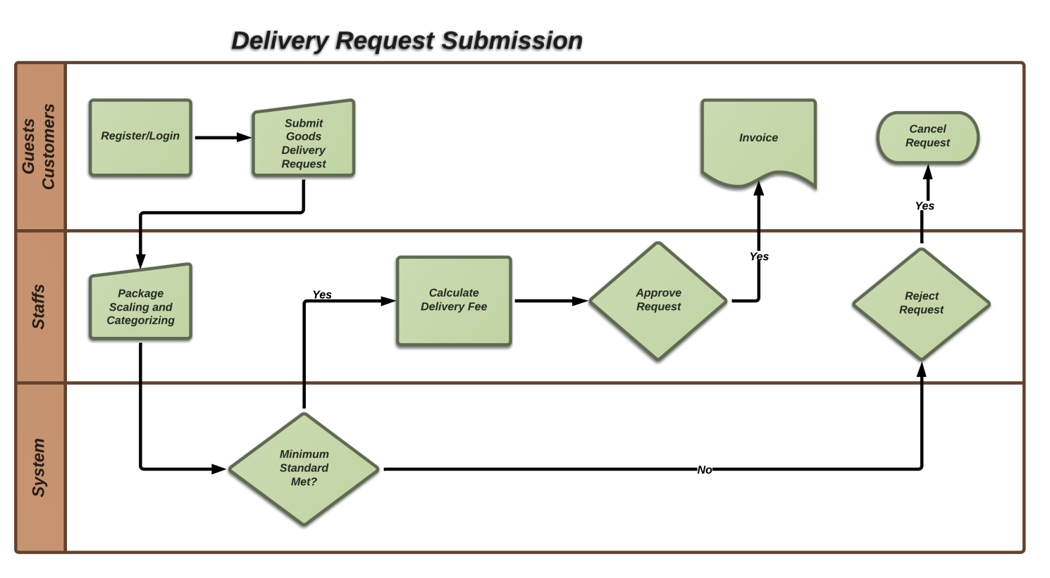

Figure . Customer make goods delivery request

The flows *Customer make goods delivery request* include the followings steps:

1. The customer login to the i-Deliver website (registration is required for guest);
2. The customer provides necessary deliver information (receiver address, detail contact, package weight and size, type of goods) to make a request; they can make a payment online via third-party service or the receiver will pay for delivery fee;
3. The staff re-scaling and categorizing package then confirm provided information to system to check package requirements and calculate delivery fee;
4. The staff approve request then make an invoice for customer if their package meet delivery standards, or they will reject request and return package to customer if not.

#### Flow 2: Staffs manage and scheduling for package delivery

The flow *Staff opens a hotel in the system* include the followings steps:

1. The Staff completes basic information of their hotel and makes a request to the system Administrator;
2. The hotel opening request is notified to the system Administrators;
3. The system Administrator check the validity of the hotel and approves of the hotel opening request;
4. The Staff continues to add images, room types, features for their hotel;
5. The Staff specifies prices and daily available statuses for each room. Until this step, their hotel is searchable, filterable, and can be booked on the I-DELIVER website;
6. The Staff installs a Facebook application for the Facebook page of their hotel (If there is no Facebook page for the hotel, the Staff must manually create one on Facebook).



Figure . Staff opens a hotel in the system

### System Features



#### Overall Use Case Diagram

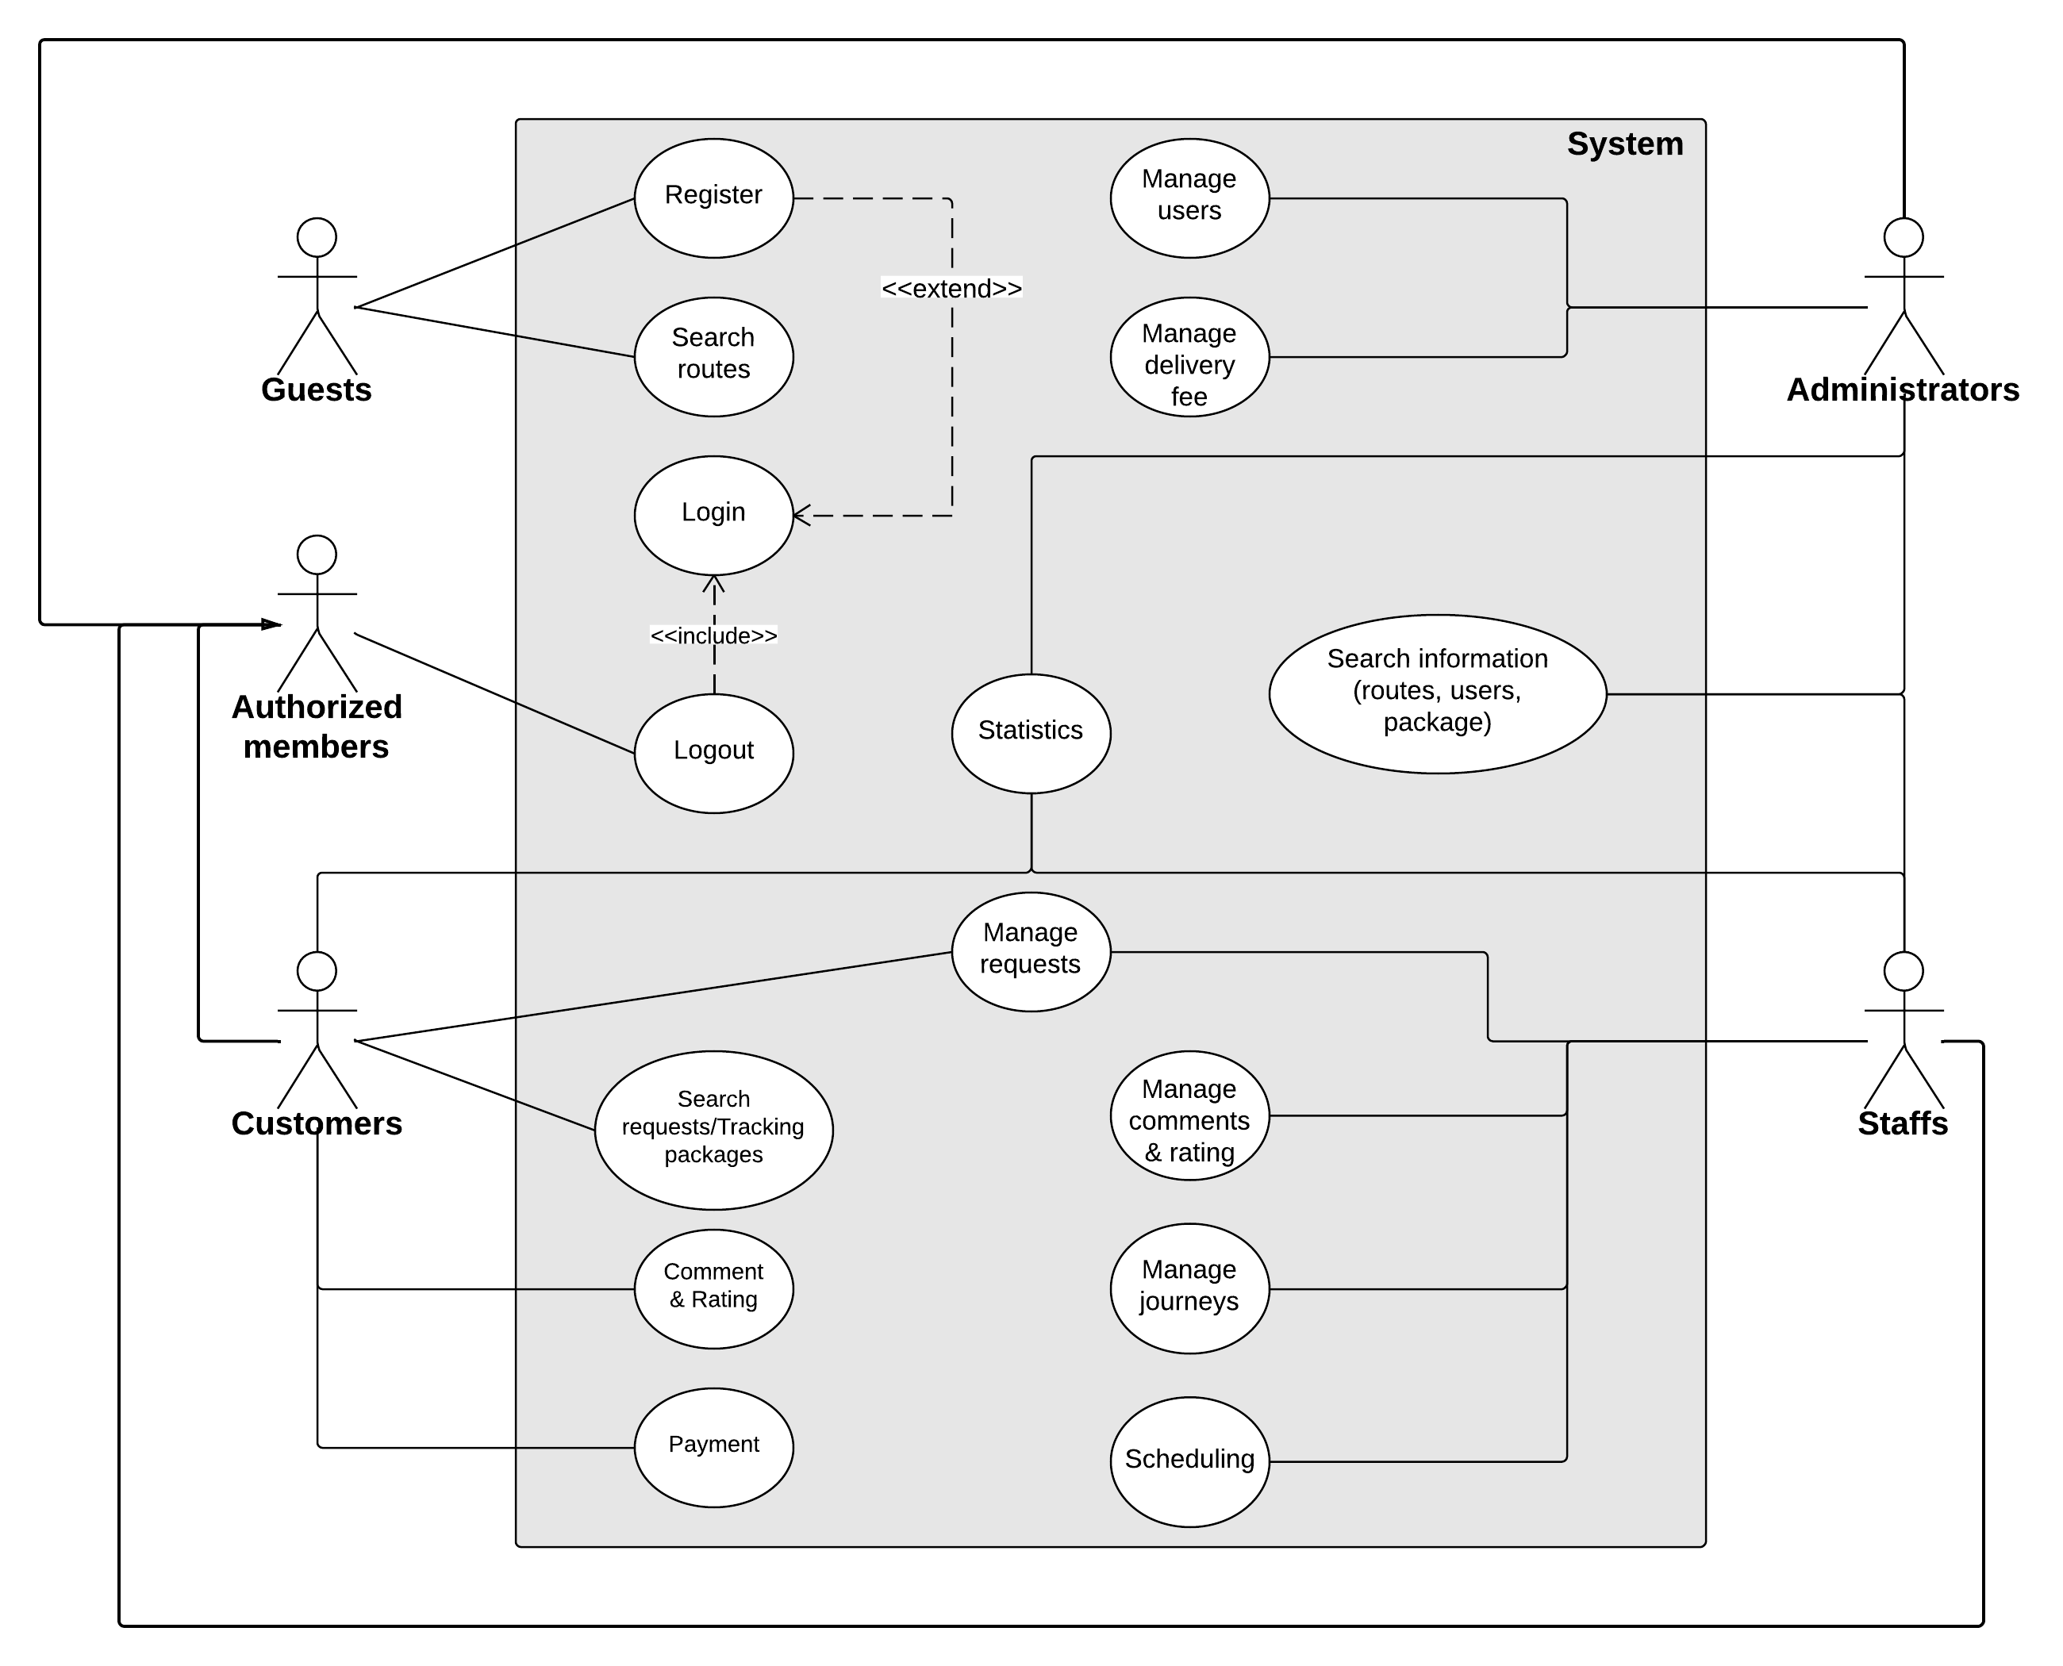

Diagram . Use case diagram

Note that only important and business-related use cases are described in details in the section below.

#### « Guest » Register

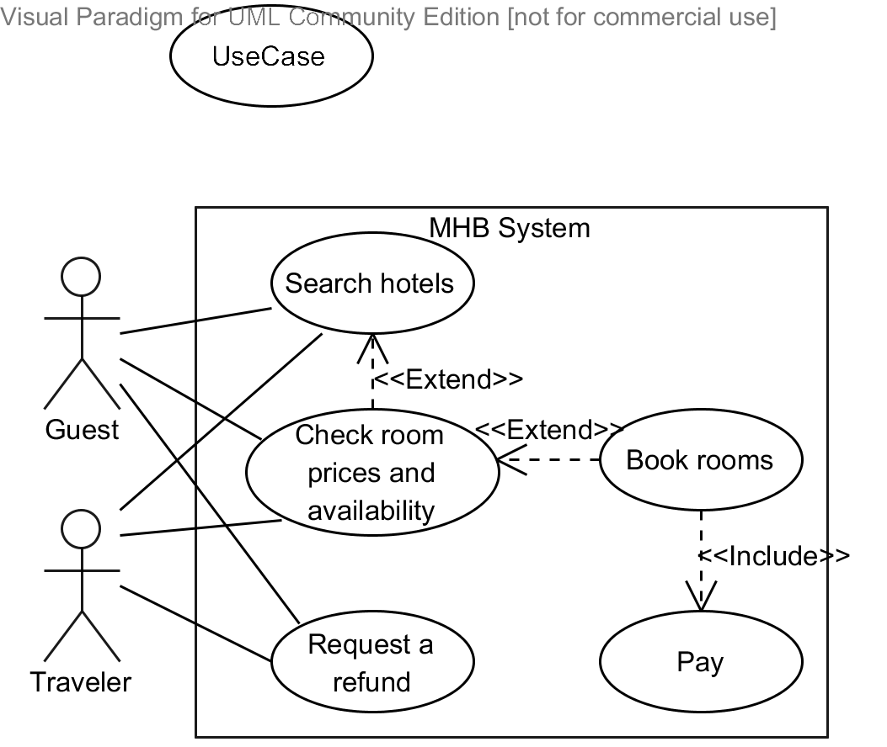

|  |  |  |  |  |
| --- | --- | --- | --- | --- |
| **– SPECIFICATION** | | | | |
| **Use-case No.** | UC001 | **Use-case Version** | |  |
| **Use-case Name** |  | | | |
| **Author** |  | | | |
| **Date** |  | **Priority** |  | |
| **Actor:**  **Summary:**  …  **Goal:**  .  **Triggers:**  .  **Preconditions:**  .  **Post Conditions:**  *On success:*.  *On failure:*.  **Main Success Scenario:**   |  |  |  | | --- | --- | --- | | **Step** | **User Action** | **System Response** | | 1. |  |  | | 2. |  |  | | 3. |  |  | | 4. |  |  | | 5. |  |  | | 6. |  |  |   **Alternative Scenario:**   |  |  |  |  | | --- | --- | --- | --- | | **No** | **Step** | **User Action** | **System Response** | | 1. | 1. |  |  | | 2. |  |  | | 2. | 1. |  |  | | 2. |  |  | | 3. | 1. |  |  | | 2. |  |  | | 3. | 1. |  |  | | 2. |  |  | | 4. | 1. |  |  | | 2. |  |  |   **Exceptions:**   |  |  |  | | --- | --- | --- | | **No** | **User Action** | **System Response** | | 1. |  |  | | 2. |  |  | | 3. |  |  | | 4. |  |  | | 5. |  |  | | 6. |  |  | | 7. |  |  | | 8. |  |  |   **Relationships:**  “Check room prices and availability” use case  **Business Rules:**   |  |  | | --- | --- | | **No** | **Business Rule Description** | | 1. |  | | 2. |  | | 3. |  | | | | | |

#### « Guest, Customer » Search information



|  |  |  |  |  |
| --- | --- | --- | --- | --- |
| **– SPECIFICATION** | | | | |
| **Use-case No.** | UC001 | **Use-case Version** | |  |
| **Use-case Name** |  | | | |
| **Author** |  | | | |
| **Date** |  | **Priority** |  | |
| **Actor:**  **Summary:**  …  **Goal:**  .  **Triggers:**  .  **Preconditions:**  .  **Post Conditions:**  *On success:*.  *On failure:*.  **Main Success Scenario:**   |  |  |  | | --- | --- | --- | | **Step** | **User Action** | **System Response** | | 1. |  |  | | 2. |  |  | | 3. |  |  | | 4. |  |  | | 5. |  |  | | 6. |  |  |   **Alternative Scenario:**   |  |  |  |  | | --- | --- | --- | --- | | **No** | **Step** | **User Action** | **System Response** | | 1. | 1. |  |  | | 2. |  |  | | 2. | 1. |  |  | | 2. |  |  | | 3. | 1. |  |  | | 2. |  |  | | 3. | 1. |  |  | | 2. |  |  | | 4. | 1. |  |  | | 2. |  |  |   **Exceptions:**   |  |  |  | | --- | --- | --- | | **No** | **User Action** | **System Response** | | 1. |  |  | | 2. |  |  | | 3. |  |  | | 4. |  |  | | 5. |  |  | | 6. |  |  | | 7. |  |  | | 8. |  |  |   **Relationships:**  “Check room prices and availability” use case  **Business Rules:**   |  |  | | --- | --- | | **No** | **Business Rule Description** | | 1. |  | | 2. |  | | 3. |  | | | | | |

#### « Customer » Post request



|  |  |  |  |  |
| --- | --- | --- | --- | --- |
| **– SPECIFICATION** | | | | |
| **Use-case No.** | UC001 | **Use-case Version** | |  |
| **Use-case Name** |  | | | |
| **Author** |  | | | |
| **Date** |  | **Priority** |  | |
| **Actor:**  **Summary:**  …  **Goal:**  .  **Triggers:**  .  **Preconditions:**  .  **Post Conditions:**  *On success:*.  *On failure:*.  **Main Success Scenario:**   |  |  |  | | --- | --- | --- | | **Step** | **User Action** | **System Response** | | 1. |  |  | | 2. |  |  | | 3. |  |  | | 4. |  |  | | 5. |  |  | | 6. |  |  |   **Alternative Scenario:**   |  |  |  |  | | --- | --- | --- | --- | | **No** | **Step** | **User Action** | **System Response** | | 1. | 1. |  |  | | 2. |  |  | | 2. | 1. |  |  | | 2. |  |  | | 3. | 1. |  |  | | 2. |  |  | | 3. | 1. |  |  | | 2. |  |  | | 4. | 1. |  |  | | 2. |  |  |   **Exceptions:**   |  |  |  | | --- | --- | --- | | **No** | **User Action** | **System Response** | | 1. |  |  | | 2. |  |  | | 3. |  |  | | 4. |  |  | | 5. |  |  | | 6. |  |  | | 7. |  |  | | 8. |  |  |   **Relationships:**  “Check room prices and availability” use case  **Business Rules:**   |  |  | | --- | --- | | **No** | **Business Rule Description** | | 1. |  | | 2. |  | | 3. |  | | | | | |

#### « Customer » Edit request



|  |  |  |  |  |
| --- | --- | --- | --- | --- |
| **– SPECIFICATION** | | | | |
| **Use-case No.** | UC001 | **Use-case Version** | |  |
| **Use-case Name** |  | | | |
| **Author** |  | | | |
| **Date** |  | **Priority** |  | |
| **Actor:**  **Summary:**  …  **Goal:**  .  **Triggers:**  .  **Preconditions:**  .  **Post Conditions:**  *On success:*.  *On failure:*.  **Main Success Scenario:**   |  |  |  | | --- | --- | --- | | **Step** | **User Action** | **System Response** | | 1. |  |  | | 2. |  |  | | 3. |  |  | | 4. |  |  | | 5. |  |  | | 6. |  |  |   **Alternative Scenario:**   |  |  |  |  | | --- | --- | --- | --- | | **No** | **Step** | **User Action** | **System Response** | | 1. | 1. |  |  | | 2. |  |  | | 2. | 1. |  |  | | 2. |  |  | | 3. | 1. |  |  | | 2. |  |  | | 3. | 1. |  |  | | 2. |  |  | | 4. | 1. |  |  | | 2. |  |  |   **Exceptions:**   |  |  |  | | --- | --- | --- | | **No** | **User Action** | **System Response** | | 1. |  |  | | 2. |  |  | | 3. |  |  | | 4. |  |  | | 5. |  |  | | 6. |  |  | | 7. |  |  | | 8. |  |  |   **Relationships:**  “Check room prices and availability” use case  **Business Rules:**   |  |  | | --- | --- | | **No** | **Business Rule Description** | | 1. |  | | 2. |  | | 3. |  | | | | | |

#### « Customer » Cancel request



|  |  |  |  |  |
| --- | --- | --- | --- | --- |
| **– SPECIFICATION** | | | | |
| **Use-case No.** | UC001 | **Use-case Version** | |  |
| **Use-case Name** |  | | | |
| **Author** |  | | | |
| **Date** |  | **Priority** |  | |
| **Actor:**  **Summary:**  …  **Goal:**  .  **Triggers:**  .  **Preconditions:**  .  **Post Conditions:**  *On success:*.  *On failure:*.  **Main Success Scenario:**   |  |  |  | | --- | --- | --- | | **Step** | **User Action** | **System Response** | | 1. |  |  | | 2. |  |  | | 3. |  |  | | 4. |  |  | | 5. |  |  | | 6. |  |  |   **Alternative Scenario:**   |  |  |  |  | | --- | --- | --- | --- | | **No** | **Step** | **User Action** | **System Response** | | 1. | 1. |  |  | | 2. |  |  | | 2. | 1. |  |  | | 2. |  |  | | 3. | 1. |  |  | | 2. |  |  | | 3. | 1. |  |  | | 2. |  |  | | 4. | 1. |  |  | | 2. |  |  |   **Exceptions:**   |  |  |  | | --- | --- | --- | | **No** | **User Action** | **System Response** | | 1. |  |  | | 2. |  |  | | 3. |  |  | | 4. |  |  | | 5. |  |  | | 6. |  |  | | 7. |  |  | | 8. |  |  |   **Relationships:**  “Check room prices and availability” use case  **Business Rules:**   |  |  | | --- | --- | | **No** | **Business Rule Description** | | 1. |  | | 2. |  | | 3. |  | | | | | |

#### « Customer » Search request



|  |  |  |  |  |
| --- | --- | --- | --- | --- |
| **– SPECIFICATION** | | | | |
| **Use-case No.** | UC001 | **Use-case Version** | |  |
| **Use-case Name** |  | | | |
| **Author** |  | | | |
| **Date** |  | **Priority** |  | |
| **Actor:**  **Summary:**  …  **Goal:**  .  **Triggers:**  .  **Preconditions:**  .  **Post Conditions:**  *On success:*.  *On failure:*.  **Main Success Scenario:**   |  |  |  | | --- | --- | --- | | **Step** | **User Action** | **System Response** | | 1. |  |  | | 2. |  |  | | 3. |  |  | | 4. |  |  | | 5. |  |  | | 6. |  |  |   **Alternative Scenario:**   |  |  |  |  | | --- | --- | --- | --- | | **No** | **Step** | **User Action** | **System Response** | | 1. | 1. |  |  | | 2. |  |  | | 2. | 1. |  |  | | 2. |  |  | | 3. | 1. |  |  | | 2. |  |  | | 3. | 1. |  |  | | 2. |  |  | | 4. | 1. |  |  | | 2. |  |  |   **Exceptions:**   |  |  |  | | --- | --- | --- | | **No** | **User Action** | **System Response** | | 1. |  |  | | 2. |  |  | | 3. |  |  | | 4. |  |  | | 5. |  |  | | 6. |  |  | | 7. |  |  | | 8. |  |  |   **Relationships:**  “Check room prices and availability” use case  **Business Rules:**   |  |  | | --- | --- | | **No** | **Business Rule Description** | | 1. |  | | 2. |  | | 3. |  | | | | | |

#### « Customer » Tracking package



|  |  |  |  |  |
| --- | --- | --- | --- | --- |
| **– SPECIFICATION** | | | | |
| **Use-case No.** | UC001 | **Use-case Version** | |  |
| **Use-case Name** |  | | | |
| **Author** |  | | | |
| **Date** |  | **Priority** |  | |
| **Actor:**  **Summary:**  …  **Goal:**  .  **Triggers:**  .  **Preconditions:**  .  **Post Conditions:**  *On success:*.  *On failure:*.  **Main Success Scenario:**   |  |  |  | | --- | --- | --- | | **Step** | **User Action** | **System Response** | | 1. |  |  | | 2. |  |  | | 3. |  |  | | 4. |  |  | | 5. |  |  | | 6. |  |  |   **Alternative Scenario:**   |  |  |  |  | | --- | --- | --- | --- | | **No** | **Step** | **User Action** | **System Response** | | 1. | 1. |  |  | | 2. |  |  | | 2. | 1. |  |  | | 2. |  |  | | 3. | 1. |  |  | | 2. |  |  | | 3. | 1. |  |  | | 2. |  |  | | 4. | 1. |  |  | | 2. |  |  |   **Exceptions:**   |  |  |  | | --- | --- | --- | | **No** | **User Action** | **System Response** | | 1. |  |  | | 2. |  |  | | 3. |  |  | | 4. |  |  | | 5. |  |  | | 6. |  |  | | 7. |  |  | | 8. |  |  |   **Relationships:**  “Check room prices and availability” use case  **Business Rules:**   |  |  | | --- | --- | | **No** | **Business Rule Description** | | 1. |  | | 2. |  | | 3. |  | | | | | |

#### « Customer » View request detail



|  |  |  |  |  |
| --- | --- | --- | --- | --- |
| **– SPECIFICATION** | | | | |
| **Use-case No.** | UC001 | **Use-case Version** | |  |
| **Use-case Name** |  | | | |
| **Author** |  | | | |
| **Date** |  | **Priority** |  | |
| **Actor:**  **Summary:**  …  **Goal:**  .  **Triggers:**  .  **Preconditions:**  .  **Post Conditions:**  *On success:*.  *On failure:*.  **Main Success Scenario:**   |  |  |  | | --- | --- | --- | | **Step** | **User Action** | **System Response** | | 1. |  |  | | 2. |  |  | | 3. |  |  | | 4. |  |  | | 5. |  |  | | 6. |  |  |   **Alternative Scenario:**   |  |  |  |  | | --- | --- | --- | --- | | **No** | **Step** | **User Action** | **System Response** | | 1. | 1. |  |  | | 2. |  |  | | 2. | 1. |  |  | | 2. |  |  | | 3. | 1. |  |  | | 2. |  |  | | 3. | 1. |  |  | | 2. |  |  | | 4. | 1. |  |  | | 2. |  |  |   **Exceptions:**   |  |  |  | | --- | --- | --- | | **No** | **User Action** | **System Response** | | 1. |  |  | | 2. |  |  | | 3. |  |  | | 4. |  |  | | 5. |  |  | | 6. |  |  | | 7. |  |  | | 8. |  |  |   **Relationships:**  “Check room prices and availability” use case  **Business Rules:**   |  |  | | --- | --- | | **No** | **Business Rule Description** | | 1. |  | | 2. |  | | 3. |  | | | | | |

#### « Customer » Payment



|  |  |  |  |  |
| --- | --- | --- | --- | --- |
| **– SPECIFICATION** | | | | |
| **Use-case No.** | UC001 | **Use-case Version** | |  |
| **Use-case Name** |  | | | |
| **Author** |  | | | |
| **Date** |  | **Priority** |  | |
| **Actor:**  **Summary:**  …  **Goal:**  .  **Triggers:**  .  **Preconditions:**  .  **Post Conditions:**  *On success:*.  *On failure:*.  **Main Success Scenario:**   |  |  |  | | --- | --- | --- | | **Step** | **User Action** | **System Response** | | 1. |  |  | | 2. |  |  | | 3. |  |  | | 4. |  |  | | 5. |  |  | | 6. |  |  |   **Alternative Scenario:**   |  |  |  |  | | --- | --- | --- | --- | | **No** | **Step** | **User Action** | **System Response** | | 1. | 1. |  |  | | 2. |  |  | | 2. | 1. |  |  | | 2. |  |  | | 3. | 1. |  |  | | 2. |  |  | | 3. | 1. |  |  | | 2. |  |  | | 4. | 1. |  |  | | 2. |  |  |   **Exceptions:**   |  |  |  | | --- | --- | --- | | **No** | **User Action** | **System Response** | | 1. |  |  | | 2. |  |  | | 3. |  |  | | 4. |  |  | | 5. |  |  | | 6. |  |  | | 7. |  |  | | 8. |  |  |   **Relationships:**  “Check room prices and availability” use case  **Business Rules:**   |  |  | | --- | --- | | **No** | **Business Rule Description** | | 1. |  | | 2. |  | | 3. |  | | | | | |

#### « Customer » Statistics



|  |  |  |  |  |
| --- | --- | --- | --- | --- |
| **– SPECIFICATION** | | | | |
| **Use-case No.** | UC001 | **Use-case Version** | |  |
| **Use-case Name** |  | | | |
| **Author** |  | | | |
| **Date** |  | **Priority** |  | |
| **Actor:**  **Summary:**  …  **Goal:**  .  **Triggers:**  .  **Preconditions:**  .  **Post Conditions:**  *On success:*.  *On failure:*.  **Main Success Scenario:**   |  |  |  | | --- | --- | --- | | **Step** | **User Action** | **System Response** | | 1. |  |  | | 2. |  |  | | 3. |  |  | | 4. |  |  | | 5. |  |  | | 6. |  |  |   **Alternative Scenario:**   |  |  |  |  | | --- | --- | --- | --- | | **No** | **Step** | **User Action** | **System Response** | | 1. | 1. |  |  | | 2. |  |  | | 2. | 1. |  |  | | 2. |  |  | | 3. | 1. |  |  | | 2. |  |  | | 3. | 1. |  |  | | 2. |  |  | | 4. | 1. |  |  | | 2. |  |  |   **Exceptions:**   |  |  |  | | --- | --- | --- | | **No** | **User Action** | **System Response** | | 1. |  |  | | 2. |  |  | | 3. |  |  | | 4. |  |  | | 5. |  |  | | 6. |  |  | | 7. |  |  | | 8. |  |  |   **Relationships:**  “Check room prices and availability” use case  **Business Rules:**   |  |  | | --- | --- | | **No** | **Business Rule Description** | | 1. |  | | 2. |  | | 3. |  | | | | | |

#### « Customer » Comment



|  |  |  |  |  |
| --- | --- | --- | --- | --- |
| **– SPECIFICATION** | | | | |
| **Use-case No.** | UC001 | **Use-case Version** | |  |
| **Use-case Name** |  | | | |
| **Author** |  | | | |
| **Date** |  | **Priority** |  | |
| **Actor:**  **Summary:**  …  **Goal:**  .  **Triggers:**  .  **Preconditions:**  .  **Post Conditions:**  *On success:*.  *On failure:*.  **Main Success Scenario:**   |  |  |  | | --- | --- | --- | | **Step** | **User Action** | **System Response** | | 1. |  |  | | 2. |  |  | | 3. |  |  | | 4. |  |  | | 5. |  |  | | 6. |  |  |   **Alternative Scenario:**   |  |  |  |  | | --- | --- | --- | --- | | **No** | **Step** | **User Action** | **System Response** | | 1. | 1. |  |  | | 2. |  |  | | 2. | 1. |  |  | | 2. |  |  | | 3. | 1. |  |  | | 2. |  |  | | 3. | 1. |  |  | | 2. |  |  | | 4. | 1. |  |  | | 2. |  |  |   **Exceptions:**   |  |  |  | | --- | --- | --- | | **No** | **User Action** | **System Response** | | 1. |  |  | | 2. |  |  | | 3. |  |  | | 4. |  |  | | 5. |  |  | | 6. |  |  | | 7. |  |  | | 8. |  |  |   **Relationships:**  “Check room prices and availability” use case  **Business Rules:**   |  |  | | --- | --- | | **No** | **Business Rule Description** | | 1. |  | | 2. |  | | 3. |  | | | | | |

#### « Customer » Rating



|  |  |  |  |  |
| --- | --- | --- | --- | --- |
| **– SPECIFICATION** | | | | |
| **Use-case No.** | UC001 | **Use-case Version** | |  |
| **Use-case Name** |  | | | |
| **Author** |  | | | |
| **Date** |  | **Priority** |  | |
| **Actor:**  **Summary:**  …  **Goal:**  .  **Triggers:**  .  **Preconditions:**  .  **Post Conditions:**  *On success:*.  *On failure:*.  **Main Success Scenario:**   |  |  |  | | --- | --- | --- | | **Step** | **User Action** | **System Response** | | 1. |  |  | | 2. |  |  | | 3. |  |  | | 4. |  |  | | 5. |  |  | | 6. |  |  |   **Alternative Scenario:**   |  |  |  |  | | --- | --- | --- | --- | | **No** | **Step** | **User Action** | **System Response** | | 1. | 1. |  |  | | 2. |  |  | | 2. | 1. |  |  | | 2. |  |  | | 3. | 1. |  |  | | 2. |  |  | | 3. | 1. |  |  | | 2. |  |  | | 4. | 1. |  |  | | 2. |  |  |   **Exceptions:**   |  |  |  | | --- | --- | --- | | **No** | **User Action** | **System Response** | | 1. |  |  | | 2. |  |  | | 3. |  |  | | 4. |  |  | | 5. |  |  | | 6. |  |  | | 7. |  |  | | 8. |  |  |   **Relationships:**  “Check room prices and availability” use case  **Business Rules:**   |  |  | | --- | --- | | **No** | **Business Rule Description** | | 1. |  | | 2. |  | | 3. |  | | | | | |

#### « System administrator » Define delivery fee value/calculating formula



|  |  |  |  |  |
| --- | --- | --- | --- | --- |
| **– SPECIFICATION** | | | | |
| **Use-case No.** | UC001 | **Use-case Version** | |  |
| **Use-case Name** |  | | | |
| **Author** |  | | | |
| **Date** |  | **Priority** |  | |
| **Actor:**  **Summary:**  …  **Goal:**  .  **Triggers:**  .  **Preconditions:**  .  **Post Conditions:**  *On success:*.  *On failure:*.  **Main Success Scenario:**   |  |  |  | | --- | --- | --- | | **Step** | **User Action** | **System Response** | | 1. |  |  | | 2. |  |  | | 3. |  |  | | 4. |  |  | | 5. |  |  | | 6. |  |  |   **Alternative Scenario:**   |  |  |  |  | | --- | --- | --- | --- | | **No** | **Step** | **User Action** | **System Response** | | 1. | 1. |  |  | | 2. |  |  | | 2. | 1. |  |  | | 2. |  |  | | 3. | 1. |  |  | | 2. |  |  | | 3. | 1. |  |  | | 2. |  |  | | 4. | 1. |  |  | | 2. |  |  |   **Exceptions:**   |  |  |  | | --- | --- | --- | | **No** | **User Action** | **System Response** | | 1. |  |  | | 2. |  |  | | 3. |  |  | | 4. |  |  | | 5. |  |  | | 6. |  |  | | 7. |  |  | | 8. |  |  |   **Relationships:**  “Check room prices and availability” use case  **Business Rules:**   |  |  | | --- | --- | | **No** | **Business Rule Description** | | 1. |  | | 2. |  | | 3. |  | | | | | |

#### « System administrator » Edit delivery fee value/ calculating formula



|  |  |  |  |  |
| --- | --- | --- | --- | --- |
| **– SPECIFICATION** | | | | |
| **Use-case No.** | UC001 | **Use-case Version** | |  |
| **Use-case Name** |  | | | |
| **Author** |  | | | |
| **Date** |  | **Priority** |  | |
| **Actor:**  **Summary:**  …  **Goal:**  .  **Triggers:**  .  **Preconditions:**  .  **Post Conditions:**  *On success:*.  *On failure:*.  **Main Success Scenario:**   |  |  |  | | --- | --- | --- | | **Step** | **User Action** | **System Response** | | 1. |  |  | | 2. |  |  | | 3. |  |  | | 4. |  |  | | 5. |  |  | | 6. |  |  |   **Alternative Scenario:**   |  |  |  |  | | --- | --- | --- | --- | | **No** | **Step** | **User Action** | **System Response** | | 1. | 1. |  |  | | 2. |  |  | | 2. | 1. |  |  | | 2. |  |  | | 3. | 1. |  |  | | 2. |  |  | | 3. | 1. |  |  | | 2. |  |  | | 4. | 1. |  |  | | 2. |  |  |   **Exceptions:**   |  |  |  | | --- | --- | --- | | **No** | **User Action** | **System Response** | | 1. |  |  | | 2. |  |  | | 3. |  |  | | 4. |  |  | | 5. |  |  | | 6. |  |  | | 7. |  |  | | 8. |  |  |   **Relationships:**  “Check room prices and availability” use case  **Business Rules:**   |  |  | | --- | --- | | **No** | **Business Rule Description** | | 1. |  | | 2. |  | | 3. |  | | | | | |

#### « System administrator » Create new staff account



|  |  |  |  |  |
| --- | --- | --- | --- | --- |
| **– SPECIFICATION** | | | | |
| **Use-case No.** | UC001 | **Use-case Version** | |  |
| **Use-case Name** |  | | | |
| **Author** |  | | | |
| **Date** |  | **Priority** |  | |
| **Actor:**  **Summary:**  …  **Goal:**  .  **Triggers:**  .  **Preconditions:**  .  **Post Conditions:**  *On success:*.  *On failure:*.  **Main Success Scenario:**   |  |  |  | | --- | --- | --- | | **Step** | **User Action** | **System Response** | | 1. |  |  | | 2. |  |  | | 3. |  |  | | 4. |  |  | | 5. |  |  | | 6. |  |  |   **Alternative Scenario:**   |  |  |  |  | | --- | --- | --- | --- | | **No** | **Step** | **User Action** | **System Response** | | 1. | 1. |  |  | | 2. |  |  | | 2. | 1. |  |  | | 2. |  |  | | 3. | 1. |  |  | | 2. |  |  | | 3. | 1. |  |  | | 2. |  |  | | 4. | 1. |  |  | | 2. |  |  |   **Exceptions:**   |  |  |  | | --- | --- | --- | | **No** | **User Action** | **System Response** | | 1. |  |  | | 2. |  |  | | 3. |  |  | | 4. |  |  | | 5. |  |  | | 6. |  |  | | 7. |  |  | | 8. |  |  |   **Relationships:**  “Check room prices and availability” use case  **Business Rules:**   |  |  | | --- | --- | | **No** | **Business Rule Description** | | 1. |  | | 2. |  | | 3. |  | | | | | |

#### « System administrator » Edit account information



|  |  |  |  |  |
| --- | --- | --- | --- | --- |
| **– SPECIFICATION** | | | | |
| **Use-case No.** | UC001 | **Use-case Version** | |  |
| **Use-case Name** |  | | | |
| **Author** |  | | | |
| **Date** |  | **Priority** |  | |
| **Actor:**  **Summary:**  …  **Goal:**  .  **Triggers:**  .  **Preconditions:**  .  **Post Conditions:**  *On success:*.  *On failure:*.  **Main Success Scenario:**   |  |  |  | | --- | --- | --- | | **Step** | **User Action** | **System Response** | | 1. |  |  | | 2. |  |  | | 3. |  |  | | 4. |  |  | | 5. |  |  | | 6. |  |  |   **Alternative Scenario:**   |  |  |  |  | | --- | --- | --- | --- | | **No** | **Step** | **User Action** | **System Response** | | 1. | 1. |  |  | | 2. |  |  | | 2. | 1. |  |  | | 2. |  |  | | 3. | 1. |  |  | | 2. |  |  | | 3. | 1. |  |  | | 2. |  |  | | 4. | 1. |  |  | | 2. |  |  |   **Exceptions:**   |  |  |  | | --- | --- | --- | | **No** | **User Action** | **System Response** | | 1. |  |  | | 2. |  |  | | 3. |  |  | | 4. |  |  | | 5. |  |  | | 6. |  |  | | 7. |  |  | | 8. |  |  |   **Relationships:**  “Check room prices and availability” use case  **Business Rules:**   |  |  | | --- | --- | | **No** | **Business Rule Description** | | 1. |  | | 2. |  | | 3. |  | | | | | |

#### « System administrator » Delete account



|  |  |  |  |  |
| --- | --- | --- | --- | --- |
| **– SPECIFICATION** | | | | |
| **Use-case No.** | UC001 | **Use-case Version** | |  |
| **Use-case Name** |  | | | |
| **Author** |  | | | |
| **Date** |  | **Priority** |  | |
| **Actor:**  **Summary:**  …  **Goal:**  .  **Triggers:**  .  **Preconditions:**  .  **Post Conditions:**  *On success:*.  *On failure:*.  **Main Success Scenario:**   |  |  |  | | --- | --- | --- | | **Step** | **User Action** | **System Response** | | 1. |  |  | | 2. |  |  | | 3. |  |  | | 4. |  |  | | 5. |  |  | | 6. |  |  |   **Alternative Scenario:**   |  |  |  |  | | --- | --- | --- | --- | | **No** | **Step** | **User Action** | **System Response** | | 1. | 1. |  |  | | 2. |  |  | | 2. | 1. |  |  | | 2. |  |  | | 3. | 1. |  |  | | 2. |  |  | | 3. | 1. |  |  | | 2. |  |  | | 4. | 1. |  |  | | 2. |  |  |   **Exceptions:**   |  |  |  | | --- | --- | --- | | **No** | **User Action** | **System Response** | | 1. |  |  | | 2. |  |  | | 3. |  |  | | 4. |  |  | | 5. |  |  | | 6. |  |  | | 7. |  |  | | 8. |  |  |   **Relationships:**  “Check room prices and availability” use case  **Business Rules:**   |  |  | | --- | --- | | **No** | **Business Rule Description** | | 1. |  | | 2. |  | | 3. |  | | | | | |

#### « System administrator » Search information



|  |  |  |  |  |
| --- | --- | --- | --- | --- |
| **– SPECIFICATION** | | | | |
| **Use-case No.** | UC001 | **Use-case Version** | |  |
| **Use-case Name** |  | | | |
| **Author** |  | | | |
| **Date** |  | **Priority** |  | |
| **Actor:**  **Summary:**  …  **Goal:**  .  **Triggers:**  .  **Preconditions:**  .  **Post Conditions:**  *On success:*.  *On failure:*.  **Main Success Scenario:**   |  |  |  | | --- | --- | --- | | **Step** | **User Action** | **System Response** | | 1. |  |  | | 2. |  |  | | 3. |  |  | | 4. |  |  | | 5. |  |  | | 6. |  |  |   **Alternative Scenario:**   |  |  |  |  | | --- | --- | --- | --- | | **No** | **Step** | **User Action** | **System Response** | | 1. | 1. |  |  | | 2. |  |  | | 2. | 1. |  |  | | 2. |  |  | | 3. | 1. |  |  | | 2. |  |  | | 3. | 1. |  |  | | 2. |  |  | | 4. | 1. |  |  | | 2. |  |  |   **Exceptions:**   |  |  |  | | --- | --- | --- | | **No** | **User Action** | **System Response** | | 1. |  |  | | 2. |  |  | | 3. |  |  | | 4. |  |  | | 5. |  |  | | 6. |  |  | | 7. |  |  | | 8. |  |  |   **Relationships:**  “Check room prices and availability” use case  **Business Rules:**   |  |  | | --- | --- | | **No** | **Business Rule Description** | | 1. |  | | 2. |  | | 3. |  | | | | | |

#### « System administrator » Statistics



|  |  |  |  |  |
| --- | --- | --- | --- | --- |
| **– SPECIFICATION** | | | | |
| **Use-case No.** | UC001 | **Use-case Version** | |  |
| **Use-case Name** |  | | | |
| **Author** |  | | | |
| **Date** |  | **Priority** |  | |
| **Actor:**  **Summary:**  …  **Goal:**  .  **Triggers:**  .  **Preconditions:**  .  **Post Conditions:**  *On success:*.  *On failure:*.  **Main Success Scenario:**   |  |  |  | | --- | --- | --- | | **Step** | **User Action** | **System Response** | | 1. |  |  | | 2. |  |  | | 3. |  |  | | 4. |  |  | | 5. |  |  | | 6. |  |  |   **Alternative Scenario:**   |  |  |  |  | | --- | --- | --- | --- | | **No** | **Step** | **User Action** | **System Response** | | 1. | 1. |  |  | | 2. |  |  | | 2. | 1. |  |  | | 2. |  |  | | 3. | 1. |  |  | | 2. |  |  | | 3. | 1. |  |  | | 2. |  |  | | 4. | 1. |  |  | | 2. |  |  |   **Exceptions:**   |  |  |  | | --- | --- | --- | | **No** | **User Action** | **System Response** | | 1. |  |  | | 2. |  |  | | 3. |  |  | | 4. |  |  | | 5. |  |  | | 6. |  |  | | 7. |  |  | | 8. |  |  |   **Relationships:**  “Check room prices and availability” use case  **Business Rules:**   |  |  | | --- | --- | | **No** | **Business Rule Description** | | 1. |  | | 2. |  | | 3. |  | | | | | |

#### « Staff » Approve request



|  |  |  |  |  |
| --- | --- | --- | --- | --- |
| **– SPECIFICATION** | | | | |
| **Use-case No.** | UC001 | **Use-case Version** | |  |
| **Use-case Name** |  | | | |
| **Author** |  | | | |
| **Date** |  | **Priority** |  | |
| **Actor:**  **Summary:**  …  **Goal:**  .  **Triggers:**  .  **Preconditions:**  .  **Post Conditions:**  *On success:*.  *On failure:*.  **Main Success Scenario:**   |  |  |  | | --- | --- | --- | | **Step** | **User Action** | **System Response** | | 1. |  |  | | 2. |  |  | | 3. |  |  | | 4. |  |  | | 5. |  |  | | 6. |  |  |   **Alternative Scenario:**   |  |  |  |  | | --- | --- | --- | --- | | **No** | **Step** | **User Action** | **System Response** | | 1. | 1. |  |  | | 2. |  |  | | 2. | 1. |  |  | | 2. |  |  | | 3. | 1. |  |  | | 2. |  |  | | 3. | 1. |  |  | | 2. |  |  | | 4. | 1. |  |  | | 2. |  |  |   **Exceptions:**   |  |  |  | | --- | --- | --- | | **No** | **User Action** | **System Response** | | 1. |  |  | | 2. |  |  | | 3. |  |  | | 4. |  |  | | 5. |  |  | | 6. |  |  | | 7. |  |  | | 8. |  |  |   **Relationships:**  “Check room prices and availability” use case  **Business Rules:**   |  |  | | --- | --- | | **No** | **Business Rule Description** | | 1. |  | | 2. |  | | 3. |  | | | | | |

#### « Staff » Reject request



|  |  |  |  |  |
| --- | --- | --- | --- | --- |
| **– SPECIFICATION** | | | | |
| **Use-case No.** | UC001 | **Use-case Version** | |  |
| **Use-case Name** |  | | | |
| **Author** |  | | | |
| **Date** |  | **Priority** |  | |
| **Actor:**  **Summary:**  …  **Goal:**  .  **Triggers:**  .  **Preconditions:**  .  **Post Conditions:**  *On success:*.  *On failure:*.  **Main Success Scenario:**   |  |  |  | | --- | --- | --- | | **Step** | **User Action** | **System Response** | | 1. |  |  | | 2. |  |  | | 3. |  |  | | 4. |  |  | | 5. |  |  | | 6. |  |  |   **Alternative Scenario:**   |  |  |  |  | | --- | --- | --- | --- | | **No** | **Step** | **User Action** | **System Response** | | 1. | 1. |  |  | | 2. |  |  | | 2. | 1. |  |  | | 2. |  |  | | 3. | 1. |  |  | | 2. |  |  | | 3. | 1. |  |  | | 2. |  |  | | 4. | 1. |  |  | | 2. |  |  |   **Exceptions:**   |  |  |  | | --- | --- | --- | | **No** | **User Action** | **System Response** | | 1. |  |  | | 2. |  |  | | 3. |  |  | | 4. |  |  | | 5. |  |  | | 6. |  |  | | 7. |  |  | | 8. |  |  |   **Relationships:**  “Check room prices and availability” use case  **Business Rules:**   |  |  | | --- | --- | | **No** | **Business Rule Description** | | 1. |  | | 2. |  | | 3. |  | | | | | |

#### « Staff » Assign package



|  |  |  |  |  |
| --- | --- | --- | --- | --- |
| **– SPECIFICATION** | | | | |
| **Use-case No.** | UC001 | **Use-case Version** | |  |
| **Use-case Name** |  | | | |
| **Author** |  | | | |
| **Date** |  | **Priority** |  | |
| **Actor:**  **Summary:**  …  **Goal:**  .  **Triggers:**  .  **Preconditions:**  .  **Post Conditions:**  *On success:*.  *On failure:*.  **Main Success Scenario:**   |  |  |  | | --- | --- | --- | | **Step** | **User Action** | **System Response** | | 1. |  |  | | 2. |  |  | | 3. |  |  | | 4. |  |  | | 5. |  |  | | 6. |  |  |   **Alternative Scenario:**   |  |  |  |  | | --- | --- | --- | --- | | **No** | **Step** | **User Action** | **System Response** | | 1. | 1. |  |  | | 2. |  |  | | 2. | 1. |  |  | | 2. |  |  | | 3. | 1. |  |  | | 2. |  |  | | 3. | 1. |  |  | | 2. |  |  | | 4. | 1. |  |  | | 2. |  |  |   **Exceptions:**   |  |  |  | | --- | --- | --- | | **No** | **User Action** | **System Response** | | 1. |  |  | | 2. |  |  | | 3. |  |  | | 4. |  |  | | 5. |  |  | | 6. |  |  | | 7. |  |  | | 8. |  |  |   **Relationships:**  “Check room prices and availability” use case  **Business Rules:**   |  |  | | --- | --- | | **No** | **Business Rule Description** | | 1. |  | | 2. |  | | 3. |  | | | | | |

#### « Staff » Update package status



|  |  |  |  |  |
| --- | --- | --- | --- | --- |
| **– SPECIFICATION** | | | | |
| **Use-case No.** | UC001 | **Use-case Version** | |  |
| **Use-case Name** |  | | | |
| **Author** |  | | | |
| **Date** |  | **Priority** |  | |
| **Actor:**  **Summary:**  …  **Goal:**  .  **Triggers:**  .  **Preconditions:**  .  **Post Conditions:**  *On success:*.  *On failure:*.  **Main Success Scenario:**   |  |  |  | | --- | --- | --- | | **Step** | **User Action** | **System Response** | | 1. |  |  | | 2. |  |  | | 3. |  |  | | 4. |  |  | | 5. |  |  | | 6. |  |  |   **Alternative Scenario:**   |  |  |  |  | | --- | --- | --- | --- | | **No** | **Step** | **User Action** | **System Response** | | 1. | 1. |  |  | | 2. |  |  | | 2. | 1. |  |  | | 2. |  |  | | 3. | 1. |  |  | | 2. |  |  | | 3. | 1. |  |  | | 2. |  |  | | 4. | 1. |  |  | | 2. |  |  |   **Exceptions:**   |  |  |  | | --- | --- | --- | | **No** | **User Action** | **System Response** | | 1. |  |  | | 2. |  |  | | 3. |  |  | | 4. |  |  | | 5. |  |  | | 6. |  |  | | 7. |  |  | | 8. |  |  |   **Relationships:**  “Check room prices and availability” use case  **Business Rules:**   |  |  | | --- | --- | | **No** | **Business Rule Description** | | 1. |  | | 2. |  | | 3. |  | | | | | |

#### « Staff » Manage time



|  |  |  |  |  |
| --- | --- | --- | --- | --- |
| **– SPECIFICATION** | | | | |
| **Use-case No.** | UC001 | **Use-case Version** | |  |
| **Use-case Name** |  | | | |
| **Author** |  | | | |
| **Date** |  | **Priority** |  | |
| **Actor:**  **Summary:**  …  **Goal:**  .  **Triggers:**  .  **Preconditions:**  .  **Post Conditions:**  *On success:*.  *On failure:*.  **Main Success Scenario:**   |  |  |  | | --- | --- | --- | | **Step** | **User Action** | **System Response** | | 1. |  |  | | 2. |  |  | | 3. |  |  | | 4. |  |  | | 5. |  |  | | 6. |  |  |   **Alternative Scenario:**   |  |  |  |  | | --- | --- | --- | --- | | **No** | **Step** | **User Action** | **System Response** | | 1. | 1. |  |  | | 2. |  |  | | 2. | 1. |  |  | | 2. |  |  | | 3. | 1. |  |  | | 2. |  |  | | 3. | 1. |  |  | | 2. |  |  | | 4. | 1. |  |  | | 2. |  |  |   **Exceptions:**   |  |  |  | | --- | --- | --- | | **No** | **User Action** | **System Response** | | 1. |  |  | | 2. |  |  | | 3. |  |  | | 4. |  |  | | 5. |  |  | | 6. |  |  | | 7. |  |  | | 8. |  |  |   **Relationships:**  “Check room prices and availability” use case  **Business Rules:**   |  |  | | --- | --- | | **No** | **Business Rule Description** | | 1. |  | | 2. |  | | 3. |  | | | | | |

#### « Staff » Search package



|  |  |  |  |  |
| --- | --- | --- | --- | --- |
| **– SPECIFICATION** | | | | |
| **Use-case No.** | UC001 | **Use-case Version** | |  |
| **Use-case Name** |  | | | |
| **Author** |  | | | |
| **Date** |  | **Priority** |  | |
| **Actor:**  **Summary:**  …  **Goal:**  .  **Triggers:**  .  **Preconditions:**  .  **Post Conditions:**  *On success:*.  *On failure:*.  **Main Success Scenario:**   |  |  |  | | --- | --- | --- | | **Step** | **User Action** | **System Response** | | 1. |  |  | | 2. |  |  | | 3. |  |  | | 4. |  |  | | 5. |  |  | | 6. |  |  |   **Alternative Scenario:**   |  |  |  |  | | --- | --- | --- | --- | | **No** | **Step** | **User Action** | **System Response** | | 1. | 1. |  |  | | 2. |  |  | | 2. | 1. |  |  | | 2. |  |  | | 3. | 1. |  |  | | 2. |  |  | | 3. | 1. |  |  | | 2. |  |  | | 4. | 1. |  |  | | 2. |  |  |   **Exceptions:**   |  |  |  | | --- | --- | --- | | **No** | **User Action** | **System Response** | | 1. |  |  | | 2. |  |  | | 3. |  |  | | 4. |  |  | | 5. |  |  | | 6. |  |  | | 7. |  |  | | 8. |  |  |   **Relationships:**  “Check room prices and availability” use case  **Business Rules:**   |  |  | | --- | --- | | **No** | **Business Rule Description** | | 1. |  | | 2. |  | | 3. |  | | | | | |

#### « Staff » Statistics



|  |  |  |  |  |
| --- | --- | --- | --- | --- |
| **– SPECIFICATION** | | | | |
| **Use-case No.** | UC001 | **Use-case Version** | |  |
| **Use-case Name** |  | | | |
| **Author** |  | | | |
| **Date** |  | **Priority** |  | |
| **Actor:**  **Summary:**  …  **Goal:**  .  **Triggers:**  .  **Preconditions:**  .  **Post Conditions:**  *On success:*.  *On failure:*.  **Main Success Scenario:**   |  |  |  | | --- | --- | --- | | **Step** | **User Action** | **System Response** | | 1. |  |  | | 2. |  |  | | 3. |  |  | | 4. |  |  | | 5. |  |  | | 6. |  |  |   **Alternative Scenario:**   |  |  |  |  | | --- | --- | --- | --- | | **No** | **Step** | **User Action** | **System Response** | | 1. | 1. |  |  | | 2. |  |  | | 2. | 1. |  |  | | 2. |  |  | | 3. | 1. |  |  | | 2. |  |  | | 3. | 1. |  |  | | 2. |  |  | | 4. | 1. |  |  | | 2. |  |  |   **Exceptions:**   |  |  |  | | --- | --- | --- | | **No** | **User Action** | **System Response** | | 1. |  |  | | 2. |  |  | | 3. |  |  | | 4. |  |  | | 5. |  |  | | 6. |  |  | | 7. |  |  | | 8. |  |  |   **Relationships:**  “Check room prices and availability” use case  **Business Rules:**   |  |  | | --- | --- | | **No** | **Business Rule Description** | | 1. |  | | 2. |  | | 3. |  | | | | | |

#### « Staff » Add a trip



|  |  |  |  |  |
| --- | --- | --- | --- | --- |
| **– SPECIFICATION** | | | | |
| **Use-case No.** | UC001 | **Use-case Version** | |  |
| **Use-case Name** |  | | | |
| **Author** |  | | | |
| **Date** |  | **Priority** |  | |
| **Actor:**  **Summary:**  …  **Goal:**  .  **Triggers:**  .  **Preconditions:**  .  **Post Conditions:**  *On success:*.  *On failure:*.  **Main Success Scenario:**   |  |  |  | | --- | --- | --- | | **Step** | **User Action** | **System Response** | | 1. |  |  | | 2. |  |  | | 3. |  |  | | 4. |  |  | | 5. |  |  | | 6. |  |  |   **Alternative Scenario:**   |  |  |  |  | | --- | --- | --- | --- | | **No** | **Step** | **User Action** | **System Response** | | 1. | 1. |  |  | | 2. |  |  | | 2. | 1. |  |  | | 2. |  |  | | 3. | 1. |  |  | | 2. |  |  | | 3. | 1. |  |  | | 2. |  |  | | 4. | 1. |  |  | | 2. |  |  |   **Exceptions:**   |  |  |  | | --- | --- | --- | | **No** | **User Action** | **System Response** | | 1. |  |  | | 2. |  |  | | 3. |  |  | | 4. |  |  | | 5. |  |  | | 6. |  |  | | 7. |  |  | | 8. |  |  |   **Relationships:**  “Check room prices and availability” use case  **Business Rules:**   |  |  | | --- | --- | | **No** | **Business Rule Description** | | 1. |  | | 2. |  | | 3. |  | | | | | |

#### « Staff » Edit trip information



|  |  |  |  |  |
| --- | --- | --- | --- | --- |
| **– SPECIFICATION** | | | | |
| **Use-case No.** | UC001 | **Use-case Version** | |  |
| **Use-case Name** |  | | | |
| **Author** |  | | | |
| **Date** |  | **Priority** |  | |
| **Actor:**  **Summary:**  …  **Goal:**  .  **Triggers:**  .  **Preconditions:**  .  **Post Conditions:**  *On success:*.  *On failure:*.  **Main Success Scenario:**   |  |  |  | | --- | --- | --- | | **Step** | **User Action** | **System Response** | | 1. |  |  | | 2. |  |  | | 3. |  |  | | 4. |  |  | | 5. |  |  | | 6. |  |  |   **Alternative Scenario:**   |  |  |  |  | | --- | --- | --- | --- | | **No** | **Step** | **User Action** | **System Response** | | 1. | 1. |  |  | | 2. |  |  | | 2. | 1. |  |  | | 2. |  |  | | 3. | 1. |  |  | | 2. |  |  | | 3. | 1. |  |  | | 2. |  |  | | 4. | 1. |  |  | | 2. |  |  |   **Exceptions:**   |  |  |  | | --- | --- | --- | | **No** | **User Action** | **System Response** | | 1. |  |  | | 2. |  |  | | 3. |  |  | | 4. |  |  | | 5. |  |  | | 6. |  |  | | 7. |  |  | | 8. |  |  |   **Relationships:**  “Check room prices and availability” use case  **Business Rules:**   |  |  | | --- | --- | | **No** | **Business Rule Description** | | 1. |  | | 2. |  | | 3. |  | | | | | |

#### « Staff » Delete a trip



|  |  |  |  |  |
| --- | --- | --- | --- | --- |
| **– SPECIFICATION** | | | | |
| **Use-case No.** | UC001 | **Use-case Version** | |  |
| **Use-case Name** |  | | | |
| **Author** |  | | | |
| **Date** |  | **Priority** |  | |
| **Actor:**  **Summary:**  …  **Goal:**  .  **Triggers:**  .  **Preconditions:**  .  **Post Conditions:**  *On success:*.  *On failure:*.  **Main Success Scenario:**   |  |  |  | | --- | --- | --- | | **Step** | **User Action** | **System Response** | | 1. |  |  | | 2. |  |  | | 3. |  |  | | 4. |  |  | | 5. |  |  | | 6. |  |  |   **Alternative Scenario:**   |  |  |  |  | | --- | --- | --- | --- | | **No** | **Step** | **User Action** | **System Response** | | 1. | 1. |  |  | | 2. |  |  | | 2. | 1. |  |  | | 2. |  |  | | 3. | 1. |  |  | | 2. |  |  | | 3. | 1. |  |  | | 2. |  |  | | 4. | 1. |  |  | | 2. |  |  |   **Exceptions:**   |  |  |  | | --- | --- | --- | | **No** | **User Action** | **System Response** | | 1. |  |  | | 2. |  |  | | 3. |  |  | | 4. |  |  | | 5. |  |  | | 6. |  |  | | 7. |  |  | | 8. |  |  |   **Relationships:**  “Check room prices and availability” use case  **Business Rules:**   |  |  | | --- | --- | | **No** | **Business Rule Description** | | 1. |  | | 2. |  | | 3. |  | | | | | |

#### « Staff » Add a station



|  |  |  |  |  |
| --- | --- | --- | --- | --- |
| **– SPECIFICATION** | | | | |
| **Use-case No.** | UC001 | **Use-case Version** | |  |
| **Use-case Name** |  | | | |
| **Author** |  | | | |
| **Date** |  | **Priority** |  | |
| **Actor:**  **Summary:**  …  **Goal:**  .  **Triggers:**  .  **Preconditions:**  .  **Post Conditions:**  *On success:*.  *On failure:*.  **Main Success Scenario:**   |  |  |  | | --- | --- | --- | | **Step** | **User Action** | **System Response** | | 1. |  |  | | 2. |  |  | | 3. |  |  | | 4. |  |  | | 5. |  |  | | 6. |  |  |   **Alternative Scenario:**   |  |  |  |  | | --- | --- | --- | --- | | **No** | **Step** | **User Action** | **System Response** | | 1. | 1. |  |  | | 2. |  |  | | 2. | 1. |  |  | | 2. |  |  | | 3. | 1. |  |  | | 2. |  |  | | 3. | 1. |  |  | | 2. |  |  | | 4. | 1. |  |  | | 2. |  |  |   **Exceptions:**   |  |  |  | | --- | --- | --- | | **No** | **User Action** | **System Response** | | 1. |  |  | | 2. |  |  | | 3. |  |  | | 4. |  |  | | 5. |  |  | | 6. |  |  | | 7. |  |  | | 8. |  |  |   **Relationships:**  “Check room prices and availability” use case  **Business Rules:**   |  |  | | --- | --- | | **No** | **Business Rule Description** | | 1. |  | | 2. |  | | 3. |  | | | | | |

#### « Staff » Edit station information



|  |  |  |  |  |
| --- | --- | --- | --- | --- |
| **– SPECIFICATION** | | | | |
| **Use-case No.** | UC001 | **Use-case Version** | |  |
| **Use-case Name** |  | | | |
| **Author** |  | | | |
| **Date** |  | **Priority** |  | |
| **Actor:**  **Summary:**  …  **Goal:**  .  **Triggers:**  .  **Preconditions:**  .  **Post Conditions:**  *On success:*.  *On failure:*.  **Main Success Scenario:**   |  |  |  | | --- | --- | --- | | **Step** | **User Action** | **System Response** | | 1. |  |  | | 2. |  |  | | 3. |  |  | | 4. |  |  | | 5. |  |  | | 6. |  |  |   **Alternative Scenario:**   |  |  |  |  | | --- | --- | --- | --- | | **No** | **Step** | **User Action** | **System Response** | | 1. | 1. |  |  | | 2. |  |  | | 2. | 1. |  |  | | 2. |  |  | | 3. | 1. |  |  | | 2. |  |  | | 3. | 1. |  |  | | 2. |  |  | | 4. | 1. |  |  | | 2. |  |  |   **Exceptions:**   |  |  |  | | --- | --- | --- | | **No** | **User Action** | **System Response** | | 1. |  |  | | 2. |  |  | | 3. |  |  | | 4. |  |  | | 5. |  |  | | 6. |  |  | | 7. |  |  | | 8. |  |  |   **Relationships:**  “Check room prices and availability” use case  **Business Rules:**   |  |  | | --- | --- | | **No** | **Business Rule Description** | | 1. |  | | 2. |  | | 3. |  | | | | | |

#### « Staff » Delete a station



|  |  |  |  |  |
| --- | --- | --- | --- | --- |
| **– SPECIFICATION** | | | | |
| **Use-case No.** | UC001 | **Use-case Version** | |  |
| **Use-case Name** |  | | | |
| **Author** |  | | | |
| **Date** |  | **Priority** |  | |
| **Actor:**  **Summary:**  …  **Goal:**  .  **Triggers:**  .  **Preconditions:**  .  **Post Conditions:**  *On success:*.  *On failure:*.  **Main Success Scenario:**   |  |  |  | | --- | --- | --- | | **Step** | **User Action** | **System Response** | | 1. |  |  | | 2. |  |  | | 3. |  |  | | 4. |  |  | | 5. |  |  | | 6. |  |  |   **Alternative Scenario:**   |  |  |  |  | | --- | --- | --- | --- | | **No** | **Step** | **User Action** | **System Response** | | 1. | 1. |  |  | | 2. |  |  | | 2. | 1. |  |  | | 2. |  |  | | 3. | 1. |  |  | | 2. |  |  | | 3. | 1. |  |  | | 2. |  |  | | 4. | 1. |  |  | | 2. |  |  |   **Exceptions:**   |  |  |  | | --- | --- | --- | | **No** | **User Action** | **System Response** | | 1. |  |  | | 2. |  |  | | 3. |  |  | | 4. |  |  | | 5. |  |  | | 6. |  |  | | 7. |  |  | | 8. |  |  |   **Relationships:**  “Check room prices and availability” use case  **Business Rules:**   |  |  | | --- | --- | | **No** | **Business Rule Description** | | 1. |  | | 2. |  | | 3. |  | | | | | |

#### « Staff » Add a route



|  |  |  |  |  |
| --- | --- | --- | --- | --- |
| **– SPECIFICATION** | | | | |
| **Use-case No.** | UC001 | **Use-case Version** | |  |
| **Use-case Name** |  | | | |
| **Author** |  | | | |
| **Date** |  | **Priority** |  | |
| **Actor:**  **Summary:**  …  **Goal:**  .  **Triggers:**  .  **Preconditions:**  .  **Post Conditions:**  *On success:*.  *On failure:*.  **Main Success Scenario:**   |  |  |  | | --- | --- | --- | | **Step** | **User Action** | **System Response** | | 1. |  |  | | 2. |  |  | | 3. |  |  | | 4. |  |  | | 5. |  |  | | 6. |  |  |   **Alternative Scenario:**   |  |  |  |  | | --- | --- | --- | --- | | **No** | **Step** | **User Action** | **System Response** | | 1. | 1. |  |  | | 2. |  |  | | 2. | 1. |  |  | | 2. |  |  | | 3. | 1. |  |  | | 2. |  |  | | 3. | 1. |  |  | | 2. |  |  | | 4. | 1. |  |  | | 2. |  |  |   **Exceptions:**   |  |  |  | | --- | --- | --- | | **No** | **User Action** | **System Response** | | 1. |  |  | | 2. |  |  | | 3. |  |  | | 4. |  |  | | 5. |  |  | | 6. |  |  | | 7. |  |  | | 8. |  |  |   **Relationships:**  “Check room prices and availability” use case  **Business Rules:**   |  |  | | --- | --- | | **No** | **Business Rule Description** | | 1. |  | | 2. |  | | 3. |  | | | | | |

#### « Staff » Edit route information



|  |  |  |  |  |
| --- | --- | --- | --- | --- |
| **– SPECIFICATION** | | | | |
| **Use-case No.** | UC001 | **Use-case Version** | |  |
| **Use-case Name** |  | | | |
| **Author** |  | | | |
| **Date** |  | **Priority** |  | |
| **Actor:**  **Summary:**  …  **Goal:**  .  **Triggers:**  .  **Preconditions:**  .  **Post Conditions:**  *On success:*.  *On failure:*.  **Main Success Scenario:**   |  |  |  | | --- | --- | --- | | **Step** | **User Action** | **System Response** | | 1. |  |  | | 2. |  |  | | 3. |  |  | | 4. |  |  | | 5. |  |  | | 6. |  |  |   **Alternative Scenario:**   |  |  |  |  | | --- | --- | --- | --- | | **No** | **Step** | **User Action** | **System Response** | | 1. | 1. |  |  | | 2. |  |  | | 2. | 1. |  |  | | 2. |  |  | | 3. | 1. |  |  | | 2. |  |  | | 3. | 1. |  |  | | 2. |  |  | | 4. | 1. |  |  | | 2. |  |  |   **Exceptions:**   |  |  |  | | --- | --- | --- | | **No** | **User Action** | **System Response** | | 1. |  |  | | 2. |  |  | | 3. |  |  | | 4. |  |  | | 5. |  |  | | 6. |  |  | | 7. |  |  | | 8. |  |  |   **Relationships:**  “Check room prices and availability” use case  **Business Rules:**   |  |  | | --- | --- | | **No** | **Business Rule Description** | | 1. |  | | 2. |  | | 3. |  | | | | | |

#### « Staff » Delete a route



|  |  |  |  |  |
| --- | --- | --- | --- | --- |
| **– SPECIFICATION** | | | | |
| **Use-case No.** | UC001 | **Use-case Version** | |  |
| **Use-case Name** |  | | | |
| **Author** |  | | | |
| **Date** |  | **Priority** |  | |
| **Actor:**  **Summary:**  …  **Goal:**  .  **Triggers:**  .  **Preconditions:**  .  **Post Conditions:**  *On success:*.  *On failure:*.  **Main Success Scenario:**   |  |  |  | | --- | --- | --- | | **Step** | **User Action** | **System Response** | | 1. |  |  | | 2. |  |  | | 3. |  |  | | 4. |  |  | | 5. |  |  | | 6. |  |  |   **Alternative Scenario:**   |  |  |  |  | | --- | --- | --- | --- | | **No** | **Step** | **User Action** | **System Response** | | 1. | 1. |  |  | | 2. |  |  | | 2. | 1. |  |  | | 2. |  |  | | 3. | 1. |  |  | | 2. |  |  | | 3. | 1. |  |  | | 2. |  |  | | 4. | 1. |  |  | | 2. |  |  |   **Exceptions:**   |  |  |  | | --- | --- | --- | | **No** | **User Action** | **System Response** | | 1. |  |  | | 2. |  |  | | 3. |  |  | | 4. |  |  | | 5. |  |  | | 6. |  |  | | 7. |  |  | | 8. |  |  |   **Relationships:**  “Check room prices and availability” use case  **Business Rules:**   |  |  | | --- | --- | | **No** | **Business Rule Description** | | 1. |  | | 2. |  | | 3. |  | | | | | |

#### « Staff » Add new coach



|  |  |  |  |  |
| --- | --- | --- | --- | --- |
| **– SPECIFICATION** | | | | |
| **Use-case No.** | UC001 | **Use-case Version** | |  |
| **Use-case Name** |  | | | |
| **Author** |  | | | |
| **Date** |  | **Priority** |  | |
| **Actor:**  **Summary:**  …  **Goal:**  .  **Triggers:**  .  **Preconditions:**  .  **Post Conditions:**  *On success:*.  *On failure:*.  **Main Success Scenario:**   |  |  |  | | --- | --- | --- | | **Step** | **User Action** | **System Response** | | 1. |  |  | | 2. |  |  | | 3. |  |  | | 4. |  |  | | 5. |  |  | | 6. |  |  |   **Alternative Scenario:**   |  |  |  |  | | --- | --- | --- | --- | | **No** | **Step** | **User Action** | **System Response** | | 1. | 1. |  |  | | 2. |  |  | | 2. | 1. |  |  | | 2. |  |  | | 3. | 1. |  |  | | 2. |  |  | | 3. | 1. |  |  | | 2. |  |  | | 4. | 1. |  |  | | 2. |  |  |   **Exceptions:**   |  |  |  | | --- | --- | --- | | **No** | **User Action** | **System Response** | | 1. |  |  | | 2. |  |  | | 3. |  |  | | 4. |  |  | | 5. |  |  | | 6. |  |  | | 7. |  |  | | 8. |  |  |   **Relationships:**  “Check room prices and availability” use case  **Business Rules:**   |  |  | | --- | --- | | **No** | **Business Rule Description** | | 1. |  | | 2. |  | | 3. |  | | | | | |

#### « Staff » Edit coach information



|  |  |  |  |  |
| --- | --- | --- | --- | --- |
| **– SPECIFICATION** | | | | |
| **Use-case No.** | UC001 | **Use-case Version** | |  |
| **Use-case Name** |  | | | |
| **Author** |  | | | |
| **Date** |  | **Priority** |  | |
| **Actor:**  **Summary:**  …  **Goal:**  .  **Triggers:**  .  **Preconditions:**  .  **Post Conditions:**  *On success:*.  *On failure:*.  **Main Success Scenario:**   |  |  |  | | --- | --- | --- | | **Step** | **User Action** | **System Response** | | 1. |  |  | | 2. |  |  | | 3. |  |  | | 4. |  |  | | 5. |  |  | | 6. |  |  |   **Alternative Scenario:**   |  |  |  |  | | --- | --- | --- | --- | | **No** | **Step** | **User Action** | **System Response** | | 1. | 1. |  |  | | 2. |  |  | | 2. | 1. |  |  | | 2. |  |  | | 3. | 1. |  |  | | 2. |  |  | | 3. | 1. |  |  | | 2. |  |  | | 4. | 1. |  |  | | 2. |  |  |   **Exceptions:**   |  |  |  | | --- | --- | --- | | **No** | **User Action** | **System Response** | | 1. |  |  | | 2. |  |  | | 3. |  |  | | 4. |  |  | | 5. |  |  | | 6. |  |  | | 7. |  |  | | 8. |  |  |   **Relationships:**  “Check room prices and availability” use case  **Business Rules:**   |  |  | | --- | --- | | **No** | **Business Rule Description** | | 1. |  | | 2. |  | | 3. |  | | | | | |

#### « Staff » Delete a coach



|  |  |  |  |  |
| --- | --- | --- | --- | --- |
| **– SPECIFICATION** | | | | |
| **Use-case No.** | UC001 | **Use-case Version** | |  |
| **Use-case Name** |  | | | |
| **Author** |  | | | |
| **Date** |  | **Priority** |  | |
| **Actor:**  **Summary:**  …  **Goal:**  .  **Triggers:**  .  **Preconditions:**  .  **Post Conditions:**  *On success:*.  *On failure:*.  **Main Success Scenario:**   |  |  |  | | --- | --- | --- | | **Step** | **User Action** | **System Response** | | 1. |  |  | | 2. |  |  | | 3. |  |  | | 4. |  |  | | 5. |  |  | | 6. |  |  |   **Alternative Scenario:**   |  |  |  |  | | --- | --- | --- | --- | | **No** | **Step** | **User Action** | **System Response** | | 1. | 1. |  |  | | 2. |  |  | | 2. | 1. |  |  | | 2. |  |  | | 3. | 1. |  |  | | 2. |  |  | | 3. | 1. |  |  | | 2. |  |  | | 4. | 1. |  |  | | 2. |  |  |   **Exceptions:**   |  |  |  | | --- | --- | --- | | **No** | **User Action** | **System Response** | | 1. |  |  | | 2. |  |  | | 3. |  |  | | 4. |  |  | | 5. |  |  | | 6. |  |  | | 7. |  |  | | 8. |  |  |   **Relationships:**  “Check room prices and availability” use case  **Business Rules:**   |  |  | | --- | --- | | **No** | **Business Rule Description** | | 1. |  | | 2. |  | | 3. |  | | | | | |

#### « Staff » Delete comment



|  |  |  |  |  |
| --- | --- | --- | --- | --- |
| **– SPECIFICATION** | | | | |
| **Use-case No.** | UC001 | **Use-case Version** | |  |
| **Use-case Name** |  | | | |
| **Author** |  | | | |
| **Date** |  | **Priority** |  | |
| **Actor:**  **Summary:**  …  **Goal:**  .  **Triggers:**  .  **Preconditions:**  .  **Post Conditions:**  *On success:*.  *On failure:*.  **Main Success Scenario:**   |  |  |  | | --- | --- | --- | | **Step** | **User Action** | **System Response** | | 1. |  |  | | 2. |  |  | | 3. |  |  | | 4. |  |  | | 5. |  |  | | 6. |  |  |   **Alternative Scenario:**   |  |  |  |  | | --- | --- | --- | --- | | **No** | **Step** | **User Action** | **System Response** | | 1. | 1. |  |  | | 2. |  |  | | 2. | 1. |  |  | | 2. |  |  | | 3. | 1. |  |  | | 2. |  |  | | 3. | 1. |  |  | | 2. |  |  | | 4. | 1. |  |  | | 2. |  |  |   **Exceptions:**   |  |  |  | | --- | --- | --- | | **No** | **User Action** | **System Response** | | 1. |  |  | | 2. |  |  | | 3. |  |  | | 4. |  |  | | 5. |  |  | | 6. |  |  | | 7. |  |  | | 8. |  |  |   **Relationships:**  “Check room prices and availability” use case  **Business Rules:**   |  |  | | --- | --- | | **No** | **Business Rule Description** | | 1. |  | | 2. |  | | 3. |  | | | | | |

#### « Staff » Clear rating



|  |  |  |  |  |
| --- | --- | --- | --- | --- |
| **– SPECIFICATION** | | | | |
| **Use-case No.** | UC001 | **Use-case Version** | |  |
| **Use-case Name** |  | | | |
| **Author** |  | | | |
| **Date** |  | **Priority** |  | |
| **Actor:**  **Summary:**  …  **Goal:**  .  **Triggers:**  .  **Preconditions:**  .  **Post Conditions:**  *On success:*.  *On failure:*.  **Main Success Scenario:**   |  |  |  | | --- | --- | --- | | **Step** | **User Action** | **System Response** | | 1. |  |  | | 2. |  |  | | 3. |  |  | | 4. |  |  | | 5. |  |  | | 6. |  |  |   **Alternative Scenario:**   |  |  |  |  | | --- | --- | --- | --- | | **No** | **Step** | **User Action** | **System Response** | | 1. | 1. |  |  | | 2. |  |  | | 2. | 1. |  |  | | 2. |  |  | | 3. | 1. |  |  | | 2. |  |  | | 3. | 1. |  |  | | 2. |  |  | | 4. | 1. |  |  | | 2. |  |  |   **Exceptions:**   |  |  |  | | --- | --- | --- | | **No** | **User Action** | **System Response** | | 1. |  |  | | 2. |  |  | | 3. |  |  | | 4. |  |  | | 5. |  |  | | 6. |  |  | | 7. |  |  | | 8. |  |  |   **Relationships:**  “Check room prices and availability” use case  **Business Rules:**   |  |  | | --- | --- | | **No** | **Business Rule Description** | | 1. |  | | 2. |  | | 3. |  | | | | | |

### Software System Attributes



#### Reliability

Information about hotels are collected via web services in such a way that preserves the most accurate and up-to-date data. There should be a mechanism that helps prevent violating referential constraints and data integrity when the system synchronizes the data from the web services.

#### Availability

N/A

#### Security

Authentication is required when the user utilizes certain functions in the system. Passwords must be encrypted so the even they are unrecognizable to even system Administrators and database Administrators. The system should also require authorization when the user tries to access an unauthorized function.

#### Maintainability

In the architecture design of the system, the responsibilities of all components should be clear and do no overlap each other.

The communications with a web service provider should be packaged in a single module independent from the rest of the system. The module should support plug-and-play, so that, when the web service provider change the structure of the web service results, or when the system must work with another web service provider, minimal changes to the rest of the system are required.

#### Portability

On the client side, the website should be accessible to anyone with a personal computer that connects to the Internet and has a browser.

#### Performance

N/A

## Entity Relationship Diagram

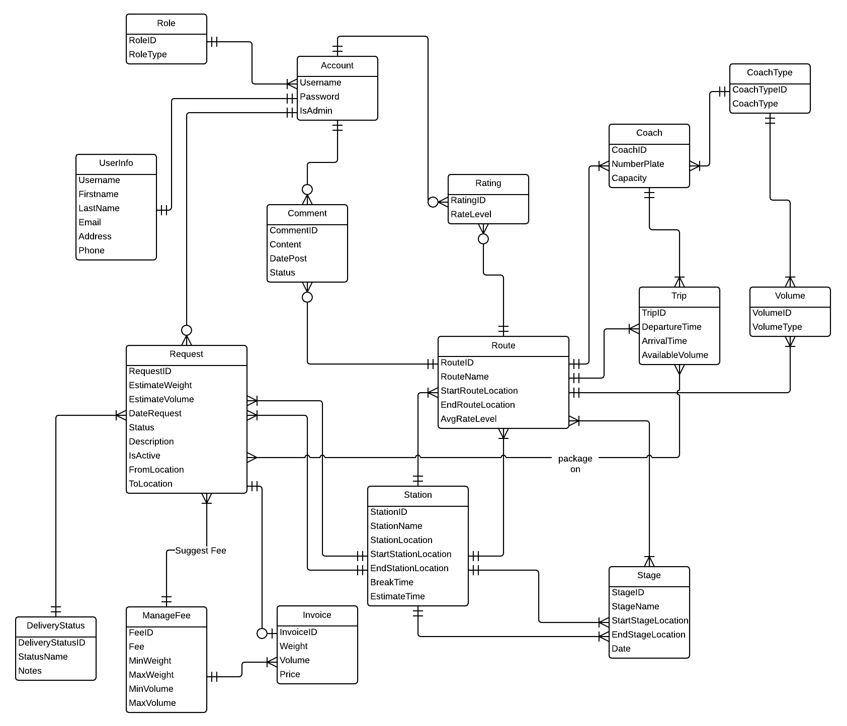

Diagram . Entity relationship diagram